*News Release*



### Liz Kohler

### Honeywell Life Care Solutions

414-828-6198

Liz.Kohler@LizKohlerPR.com

#### Enhanced Genesis Touch™ Gives Patients

#### PREVENTATIVE Tool sET for Chronic Care Management

**LOS ANGELES — May 3, 2015 —** Honeywell (**NYSE: HON**) recently released the newest version of its wireless, remote patient monitor – Genesis Touch™ – that features new peripherals and vital sign reporting options for patients who want to monitor and report their biometrics with enhanced mobility.

Providing a [preventative solution to help patients](https://www.honeywelllifecare.com/lifestream-products/genesis-touch/) manage chronic illnesses such as diabetes, Genesis Touch v3.2 from Honeywell Life Care Solutions features wireless Bluetooth compatibility with select glucometers to automatically measure and report glucose levels to health care providers. In addition, patients now have the new option of manually reporting blood glucose levels (if using other glucometers), peak flow readings and PT-INR values to their healthcare provider.

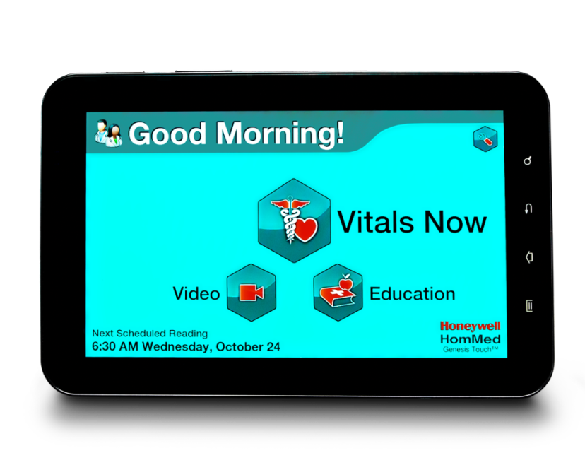

"Healthcare providers repeatedly tell us that access to expanded biometric information from patients outside the hospital leads to more successful health outcomes," said John Bojanowski, president of Honeywell Life Care Solutions. "The new reporting features of Genesis Touch provide patients with a more comprehensive picture of their health, which results in better overall engagement and puts patients more firmly in control of managing their own healthcare."

In addition to the new glucometer and vital sign reporting options, the Genesis Touch 3.2 features a new French-Canadian language option, in addition to the existing Spanish and English options. This provides patients with verbal and written menus, prompts, educational tools and questions from the healthcare provider in three language options, mitigating the effect of any language barriers that may exist.

The Genesis Touch’s product offering also includes the following:

* A **One-Touch Video** feature allows patients to simply touch the “Video” button on the tablet’s screen to be linked into a scheduled video conference call with up to 12 other parties.
* As an FDA-registered personal health device, the Genesis Touch delivers **stability and enhanced security** for patient users, securing patient data to meet HIPAA requirements. A tamper-resistant interface protects the device and its information.
* Wireless communication is supported by a standard 4G cellular data plan, as well as integrated Wi-Fi capabilities. Additionally the Genesis Touch has a **4G Video over Cellular communications option**. Customers who want to use the integrated 4G cellular radio for video collaboration can purchase a 2G plan through Honeywell for less than the cost of a traditional data plan, which will enhance the clarity of the device’s video technology to ensure patients have access to the technology support they need, whether they are at home or on the go.

As with all Genesis personal health devices, the Genesis Touch will be supported on the healthcare provider side by the LifeStream Management Suite, which seamlessly integrates the patient’s device-collected information and other point-of-care applications into a single cloud-based platform, allowing patients, families and healthcare providers easy, secure access to patient information via the Internet.

**About Honeywell:**

Honeywell (www.honeywell.com) is a Fortune 100 diversified technology and manufacturing leader, serving customers worldwide with aerospace products and services; control technologies for buildings, homes and industry; turbochargers; and performance materials. Based in Morris Township, N.J., Honeywell's shares are traded on the New York, London, and Chicago Stock Exchanges. For more news and information on Honeywell, please visit [www.honeywellnow.com](http://www.honeywellnow.com).

**About Honeywell Life Care Solutions:**

Headquartered in Brookfield, Wis., Honeywell Life Care Solution (formerly Honeywell HomMed), part of Honeywell Automation and Control Solutions, is a global leader in remote patient care through population health management solutions and telehealth, providing the healthcare industry with integrated product and service solutions designed to improve the quality of patients' lives and reduce the cost of healthcare. For more information about Honeywell Life Care Solutions, please visit [www.honeywelllifecare.com](http://www.honeywelllifecare.com).

This release contains certain statements that may be deemed “forward-looking statements” within the meaning of Section 21E of the Securities Exchange Act of 1934. All statements, other than statements of historical fact, that address activities, events or developments that we or our management intends, expects, projects, believes or anticipates will or may occur in the future are forward-looking statements. Such statements are based upon certain assumptions and assessments made by our management in light of their experience and their perception of historical trends, current economic and industry conditions, expected future developments and other factors they believe to be appropriate. The forward-looking statements included in this release are also subject to a number of material risks and uncertainties, including but not limited to economic, competitive, governmental, and technological factors affecting our operations, markets, products, services and prices. Such forward-looking statements are not guarantees of future performance, and actual results, developments and business decisions may differ from those envisaged by such forward-looking statements.

# # #